# Work Instructions for Direct Deployment

## Purpose

Step by Step process for Direct Deployment from CICD Automation tool.

## Prerequisites



* Need DevOps Solution to be imported in the Instances.
* Microsoft Flow for Dynamics Source Control.
* App need to be registered in Azure environment

## Direct Deployment

### Create Record in Dynamics Source Control

1. Login to Dynamics 365 instance.
2. Click on Deployment HUB.

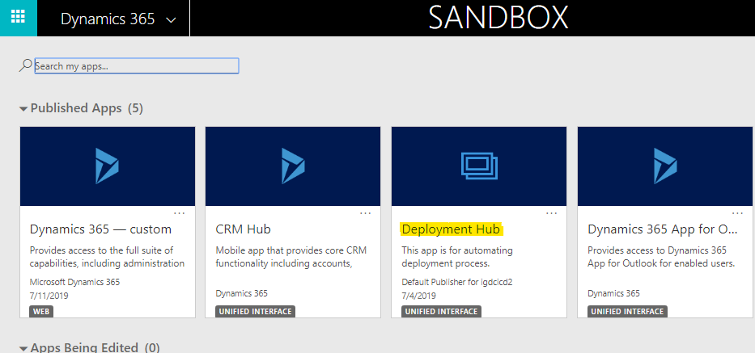

1. Navigate to Dynamic Source Control, As shown as in the below image.

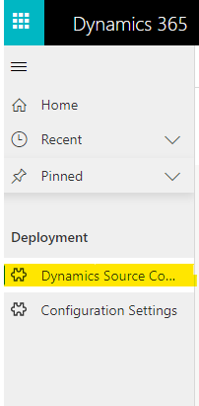

1. Click New button. New Dynamics Source Control will appear as shown below.

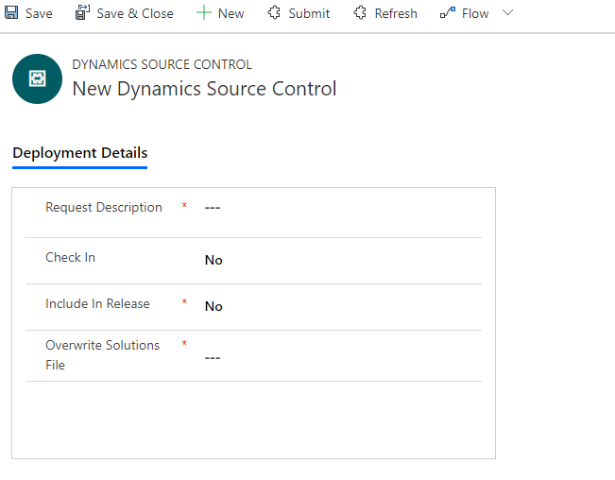

1. For Direct Deployment set below values to respective fields and Click on Save.

|  |  |
| --- | --- |
| **Field** | **Value** |
| Check In | No |
| Include In Release | No |
| Overwrite Solutions File | No |
| Request Description | Please enter detailed description |

### Deployment Instance

1. Deployment Instance is to deploy/Import multiple solutions to target instance at a time.
2. Go to Deployment Details tab. Select Add New Deployment Instance.

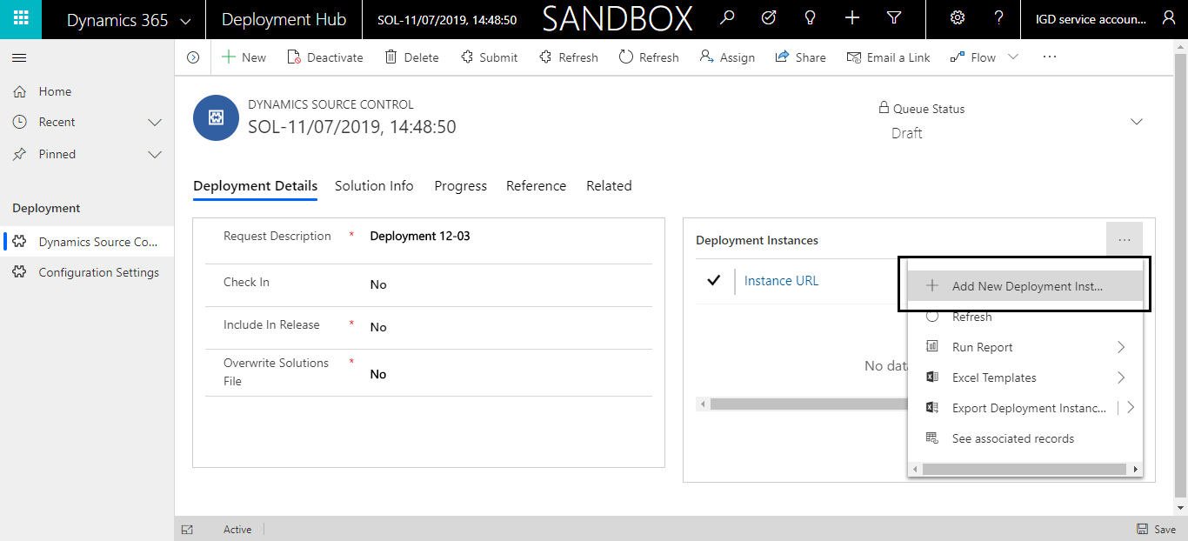

1. Deployment Instance record opens, provide all the required details

|  |  |
| --- | --- |
| Instance URL | Organization Service URL of target instance |
| User Name | Username of target instance |
| Password | Password of target instance |

**Note:** Password will be stored in CRM as encrypted format.

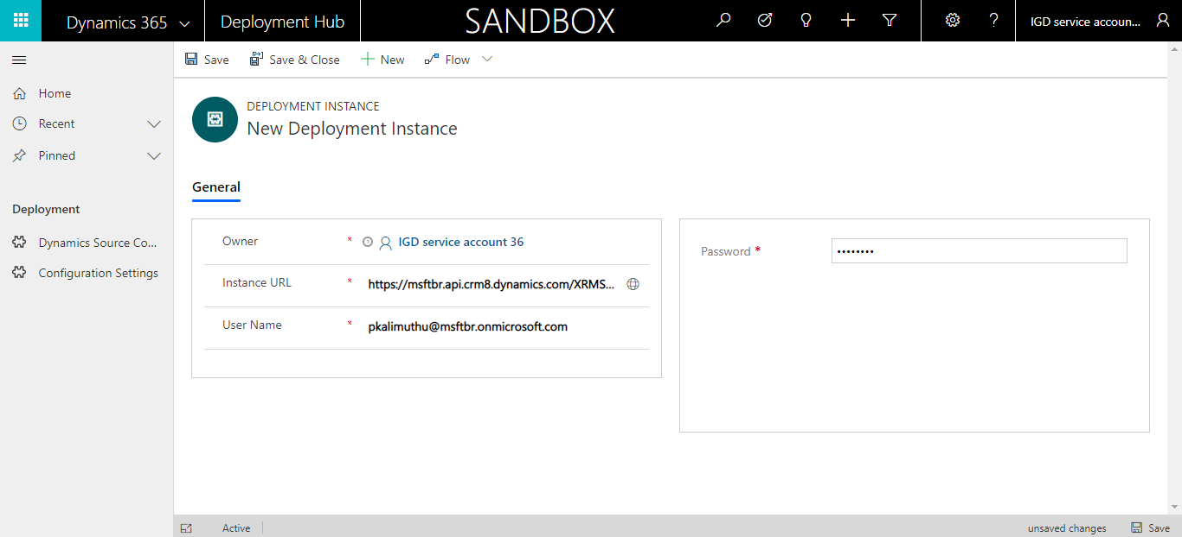

1. Save and close the record.

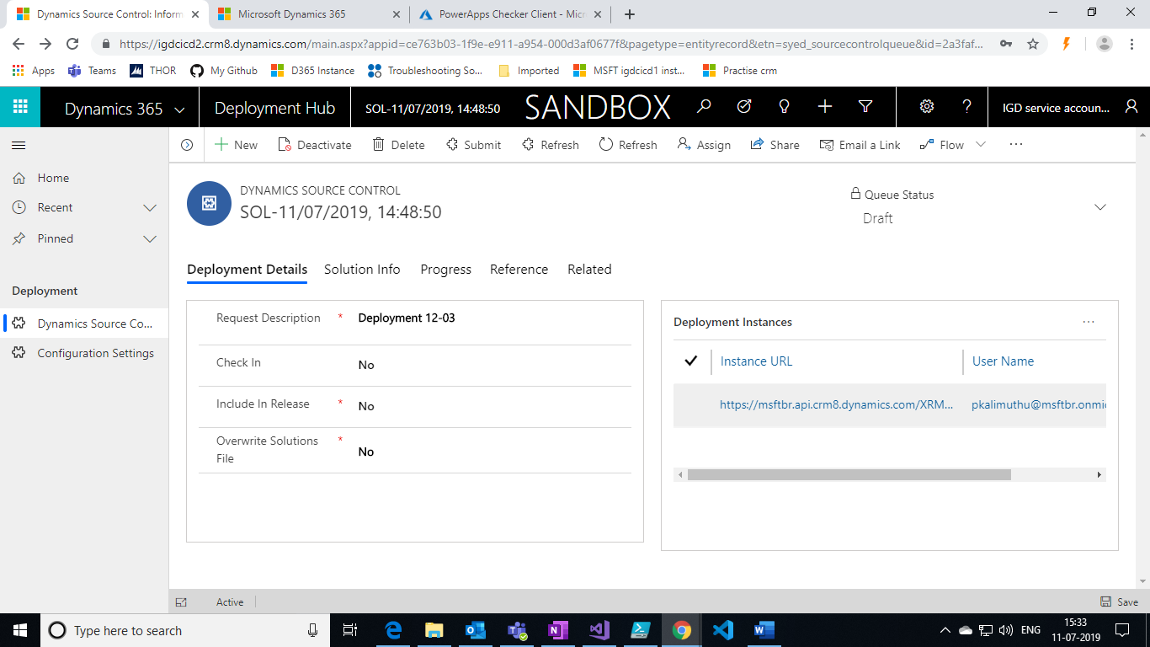

1. We can add more than one Deployment Instances record to deploy solutions to target instance.

### Adding Master and Merge solutions

#### Master Solution

We can add any number of solutions in **Master Solution** grid to deploy in the Target Instance.

Please follow the below steps to add Master Solution record.

1. Navigate to “**Solution Info**” tab, click Add New Master solution.

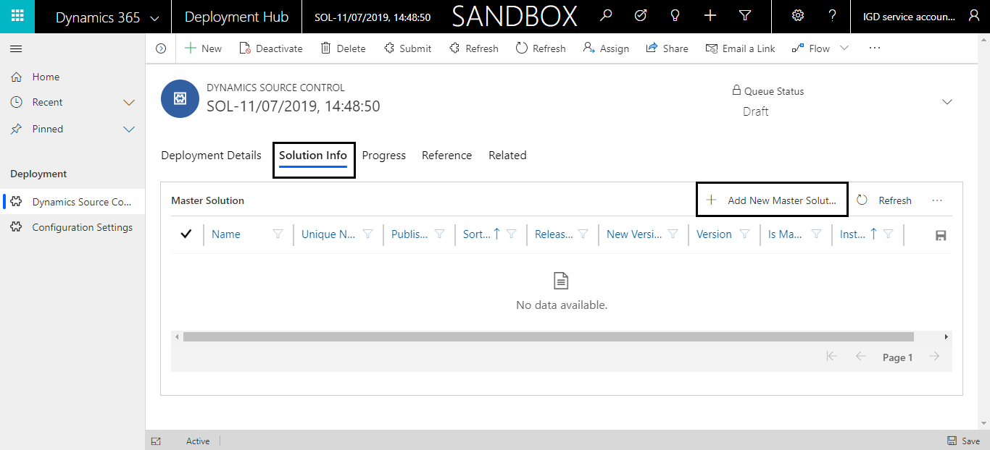

1. New Master Solution record will appear. In **CRM Solution** lookup all unmanaged CRM solutions will populated in this lookup. Please select the solution which you want to deploy in Target. Once you select **CRM Solutions** other fields will be populated automatically.

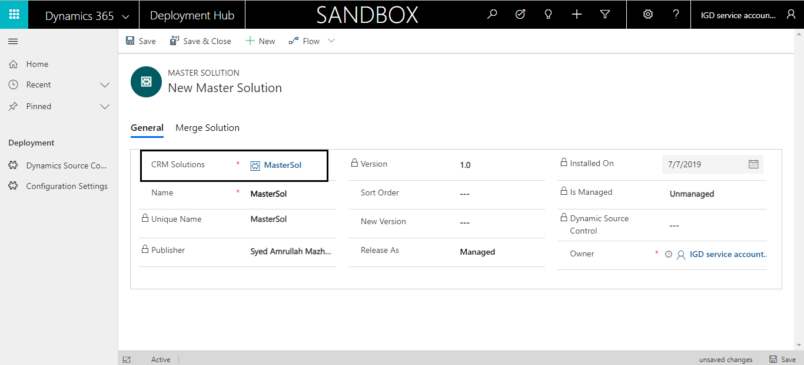

1. Set below fields based on requirement

|  |  |
| --- | --- |
| **Field** | **Description** |
| Release As | Import solution either as managed or unmanaged |
| Sort Order | When there is Multiple Master, Based on Sort Order solution are imported in Target Instance. |

1. Save the record.

#### Merge Solution

To Merge One or More Solutions to One Solution (**Master Solution**) and Deploy the Master Solution to Target Instance. Please follow below steps to Merge Solutions.

1. Go to Merge Solution tab inside master solution record, click Add New Merge Solution.

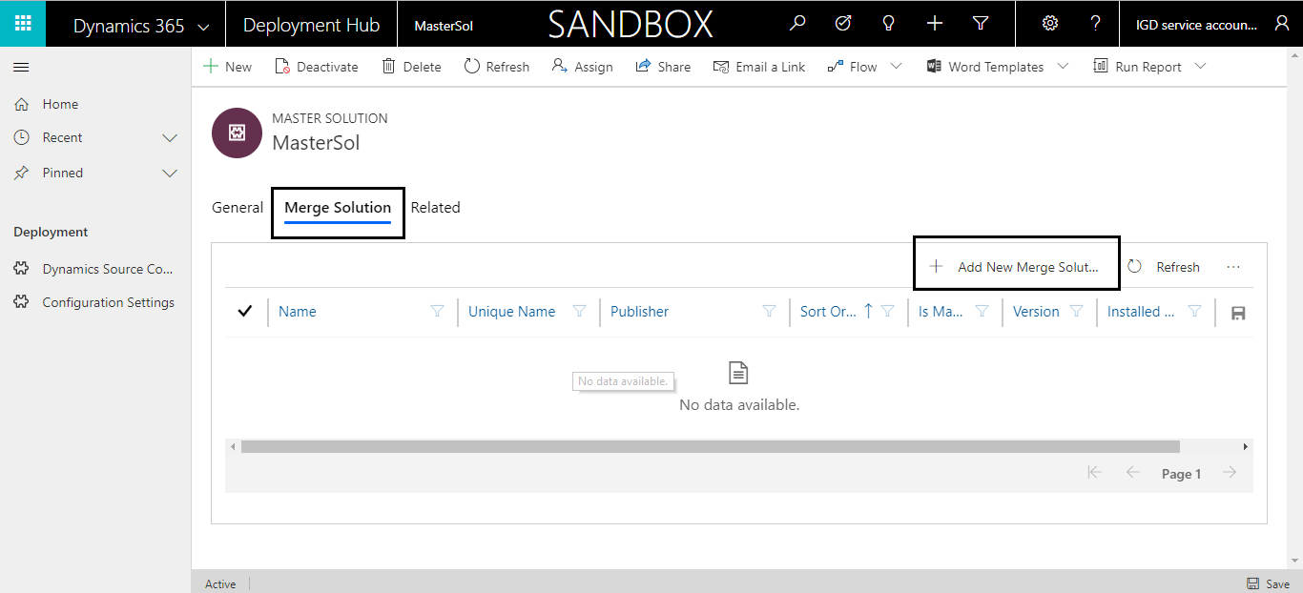

1. In **CRM Solution** lookup all unmanaged CRM solutions will populated in this lookup. Please select the solution which needs to be merged to Master Solution. Once you select **CRM Solutions** other fields will be populated automatically. Merge solution gets associated to master solution.

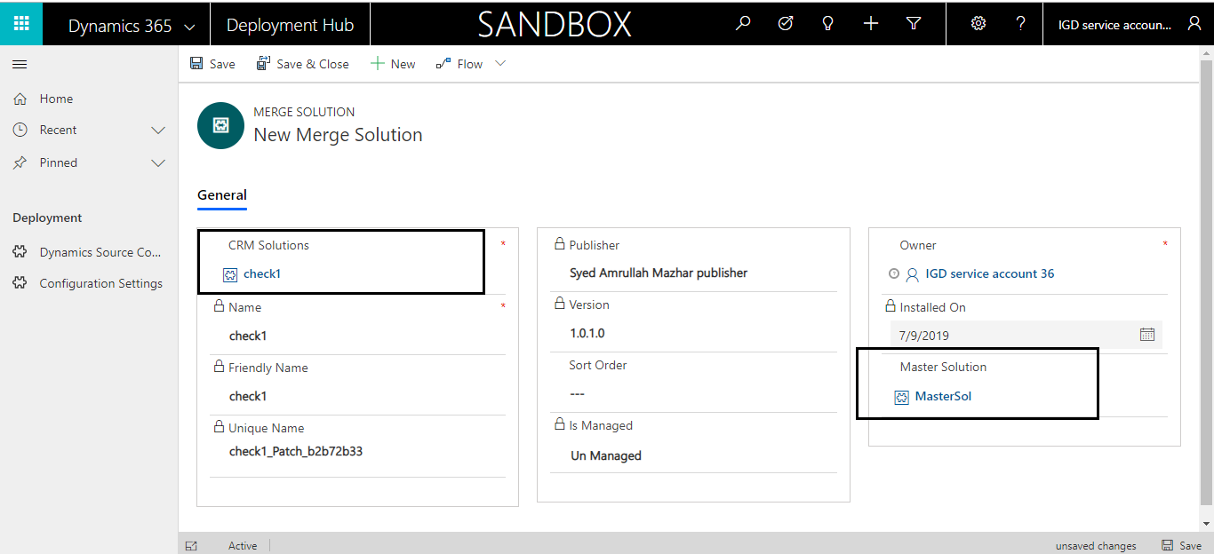

1. Save and close the record.

### Start deployment process.

1. Once all prerequisites are done, click on submit button.

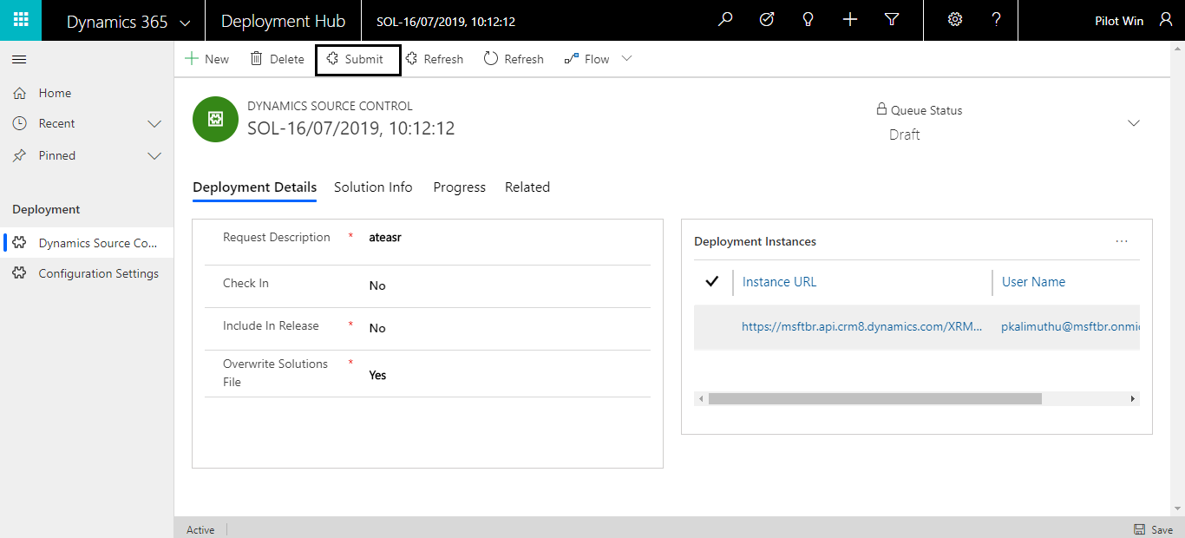

1. After submit button is clicked Queue Status will be changed to Queued and process gets start in background.
2. If in between any pop up appears for credentials provide azure credentials where app registered for solution checker using PowerShell module.

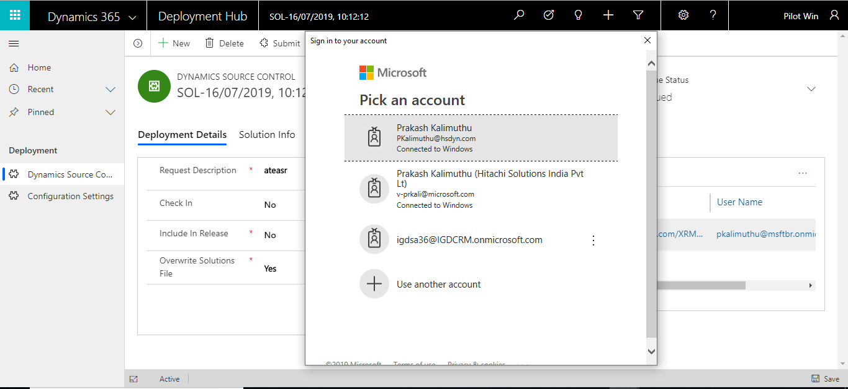

1. To check live status, refer monitoring web jobs.

### Monitoring Web Jobs.

1. In Progress Tab, Web Jobs will be available. Please click on Refresh button to see the Deployment Progress in live.
2. At the end of the process, Logs will be available as Text file in Progress Details section.

